**Task 6 : Install docker on EC2 and explore the docker commands (docker images, containers)**

**Installing Docker on EC2 :**

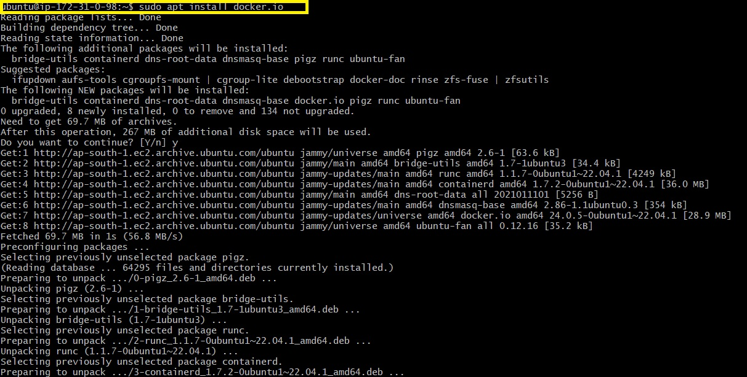



**Exploring Docker Commands (Docker images, containers) :**

